Directions to Lubrecht Experimental Forest
The drive will take between 30 and 45 minutes from Missoula, depending on road conditions.
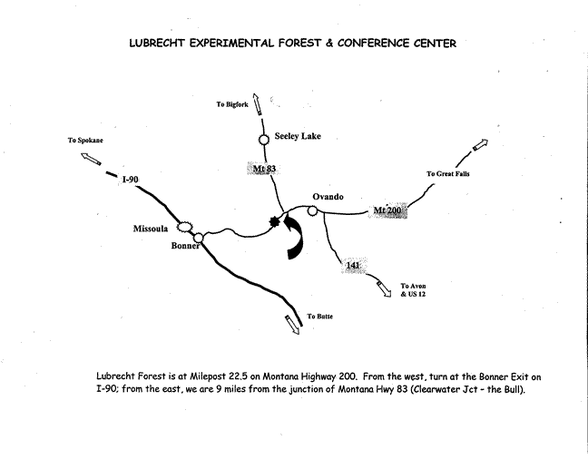
From Missoula on Interstate 90 proceed east for approximately five miles and take Exit 109, the Bonner/Great Falls/Highway 200 Exit. Proceed east on Montana Highway 200 past the Town Pump, through Milltown and Bonner, and past the small town of Potomac at mile marker 16. (The Potomac Store and Bar is the last such establishment before Lubrecht). Continue past mile marker 22 and the Garnet Range Road.
DO NOT TURN on the Garnet Range Road.
Continue PAST the Garnet Range Road entrance for about 0.2 mile and look for the entrance sign to the Lubrecht Forest headquarters and Conference Center on the east (right) side of the Highway.
A few hundred feet beyond the timbered arch entry way, the road forks at log cabin. This road circles the Headquaters Area. To reach the Foresrty Center, Lodge, and Apartments turn left. The first building on the right is the Forestry Center where you can pick up keys for your stay at the Lodge or cabins. If you continue past the Forestry Center the next building on the right is the Lodge. The Lodge parking lot is on the left, although there are six parking/unloading spaces in front of the Lodge. Please use one of these two areas for parking. To access the cabins, dinning hall, pavilion and start of the cross country trails continue past the Lodge until you reach a large parking lot, or take a right at the fork near the entrance and log cabin. The road is a loop.

